**Magnetron Sputtering**

Sputter deposition is a physical vapor deposition (PVD) method of thin film deposited by sputtering. The general sputtering method can be used to prepare a variety of materials such as metals, semiconductors, insulators, etc., and has the advantages of simple equipment, easy control, large coating area, and strong adhesion, and the magnetron sputtering method developed in the 1970s achieves high speed, low temperature, and low damage.

**What is sputtering?** The principle of Sputtering is to use the energy of a plasma (partially ionized gas) on the surface of a target (cathode), to pull the atoms of the material one by one and deposit them on the substrate.

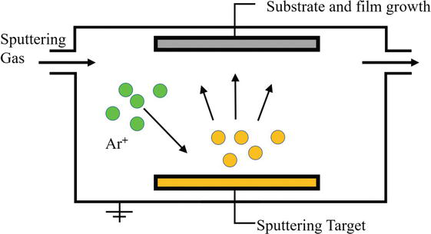

1. **Principle of magnetron sputtering**

Adding a closed magnetic field parallel to the target surface in the bipolar sputtering, the secondary electron is bound to a specific area of the target surface to enhance the ionization efficiency by means of the orthogonal electromagnetic field formed on the surface of the target, increasing the ion density and energy, and finally realizing the high-rate sputtering. The above statement is the concept of magnetron sputtering.

Magnetron sputtering is a dominant technique to grow thin films because a large quantity of thin films can be prepared at relatively high purity and low cost. This involves ejecting material from a “target” that is a source onto a “substrate” such as a silicon wafer, as shown in [Figure 1](https://www.intechopen.com/online-first/63559#F1).

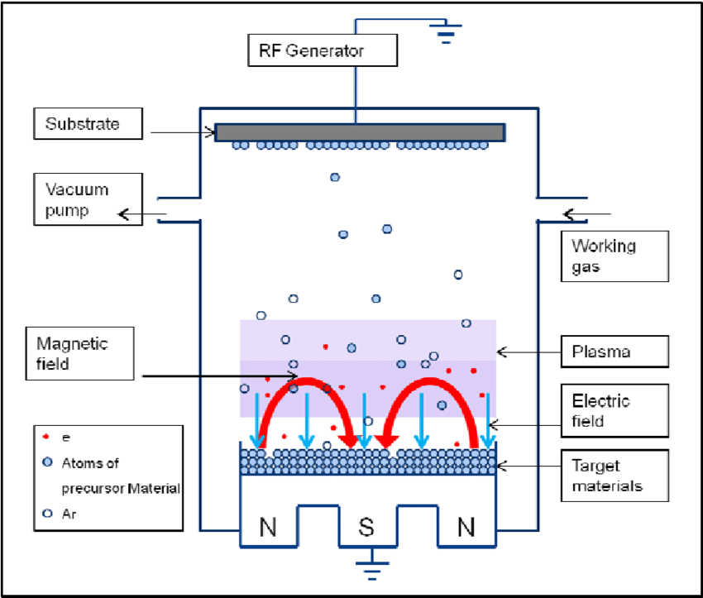 **Figure 1.**Schematic diagram of magnetron sputtering.

Magnetron sputtering is the collision process between incident particles and targets. Since high-speed sputtering is performed at a low pressure, it is necessary to effectively increase the ionization rate of the gas. The incident particle undergoes a complex scattering process in the target, collides with the target atom, and transmits part of the momentum to the target atom, which in turn collides with other target atoms to form a cascade process. During this cascade, certain target atoms near the surface gain sufficient momentum for outward motion and are sputtered out of the target. Magnetron sputtering increases the plasma density by introducing a magnetic field on the surface of the target cathode and utilizing the constraints of the magnetic field on the charged particles to increase the sputtering rate.

Magnetron sputtering includes many types, such as direct current (DC) magnetron sputtering and radio frequency (RF) magnetron sputtering, each has a different working principle and application objects. The main advantage of RF magnetron sputtering over DC magnetron sputtering is that it does not require the target as an electrode be electrically conductive. Therefore, any material can be sputter-deposited theoretically using RF magnetron sputtering.

But there is one thing in common for any type of magnetron sputtering: the interaction between the magnetic field and the electric field causes the electrons to spiral in the vicinity of the target surface, thereby increasing the probability that electrons will strike the argon gas to generate ions. The generated ions collide with the target surface under the action of an electric field to sputter the target. The target source is divided into balanced and unbalanced types; the balanced target source is uniformly coated, and the unbalanced target coating layer and the substrate have strong bonding force.

Balanced target sources are mostly used in semiconductor optical films, and unbalanced are mostly used in wear decorative films. Sputtering metals and alloys with a magnetron target is easy, and it is convenient for ignition and sputtering. Magnetron reactive sputtering insulators appear to be easy, but it is difficult for practical operations.

The magnetron cathodes are roughly classified into an equilibrium state and an unbalanced magnetron cathode according to the distribution of the magnetic field configuration. Cooling is necessary for all sources (magnetron, multiarc, ion) because a large part of the energy is converted to heat. If there is no cooling or insufficient cooling, this heat will cause the target temperature to reach more than 1000°C to dissolve the entire target.

**Limitations**

1. Relatively low coating rates

2. The RF generation is more expensive than a DC voltage source

3. For large rectangular cathodes (> 1m), unevenness in the plasma density (layer thickness distribution) may occur.

Do The Meds You Take To Curb Cholesterol Lower Your Heart Disease Risk?

A surprising answer from a new study.

0 seconds of 58 secondsVolume 0%

**2. Applications of magnetron sputtering**

Main uses of magnetron sputtering are the following:

1. Various functional films: such as films having absorption, transmission, reflection, refraction, polarization, and so on. For example, a silicon nitride antireflection film is deposited at a low temperature to improve the photoelectric conversion efficiency of the solar cell.
2. Applications in the field of decoration, such as various total reflection films and translucent films, such as cell phone cases, mice, etc.
3. As a nonthermal coating technology in the field of microelectronics, mainly used in chemical vapor deposition (CVD) or metal organics.
4. Chemical vapor deposition (MOCVD) growth is difficult and unsuitable material film deposition, and a very uniform film of a large area can be obtained.
5. In the field of optics: if closed-field unbalanced magnetron sputtering technology has also been applied in optical films (such as antireflection film), low-emissivity glass, and transparent conductive glass. In particular, transparent conductive glass is widely used in flat panel display devices, solar cells, microwave and RF shielding devices, and devices, sensors, and the like.
6. In the machining industry, the surface deposition technology of surface functional film, super hard film, and self-lubricating film has been developed since its inception, which can effectively improve surface hardness, composite toughness, wear resistance, and high temperature chemical stability. Performance greatly increases the service life of coated products.

In addition to the abovementioned fields that have been widely used, magnetron sputtering plays an important role in the research of high-temperature superconducting thin films, ferroelectric thin films, giant magnetoresistive thin films, thin film luminescent materials, solar cells, and memory alloy thin films.